WEEK – 4

REST - Get country based on country code

Nipuna

Superset id:6432842

**REST - Get country based on country code**   
  
Write a REST service that returns a specific country based on country code. The country code should be case insensitive.  
  
**Controller**: com.cognizant.spring-learn.controller.CountryController  
**Method Annotation:** @GetMapping("/countries/{code}")  
**Method Name**: getCountry(String code)  
**Method Implemetation**: Invoke countryService.getCountry(code)   
**Service Method:**com.cognizant.spring-learn.service.CountryService.getCountry(String code)  
  
**Service Method Implementation**:

* Get the country code using @PathVariable
* Get country list from country.xml
* Iterate through the country list
* Make a case insensitive matching of country code and return the country.
* Lambda expression can also be used instead of iterating the country list

**Sample Request**: http://localhost:8083/country/in  
  
**Sample Response**:

{

  "code": "IN",

  "name": "India"

}

Solution:

**country.xml**

<?xml version="1.0" encoding="UTF-8"?>

<beans xmlns="<http://www.springframework.org/schema/beans>"

       xmlns:xsi="<http://www.w3.org/2001/XMLSchema-instance>"

       xsi:schemaLocation="<http://www.springframework.org/schema/beans>

<http://www.springframework.org/schema/beans/spring-beans.xsd>">

    <bean id="countryList" class="java.util.ArrayList">

        <constructor-arg>

            <list>

                <bean class="com.cognizant.spring_learn.Country">

                    <property name="code" value="IN" />

                    <property name="name" value="India" />

                </bean>

                <bean class="com.cognizant.spring_learn.Country">

                    <property name="code" value="US" />

                    <property name="name" value="United States" />

                </bean>

                <bean class="com.cognizant.spring_learn.Country">

                    <property name="code" value="JP" />

                    <property name="name" value="Japan" />

                </bean>

                <bean class="com.cognizant.spring_learn.Country">

                    <property name="code" value="DE" />

                    <property name="name" value="Germany" />

                </bean>

            </list>

        </constructor-arg>

    </bean>

</beans>

**CountryService.java in service package:**

package com.cognizant.spring_learn.service;

import com.cognizant.spring_learn.Country;

import org.slf4j.Logger;

import org.slf4j.LoggerFactory;

import org.springframework.context.ApplicationContext;

import org.springframework.context.support.ClassPathXmlApplicationContext;

import org.springframework.stereotype.Service;

import java.util.List;

@Service

public class CountryService {

    private static final Logger LOGGER = LoggerFactory.getLogger(CountryService.class);

    public Country getCountry(String code) {

        LOGGER.debug("START");

        ApplicationContext context = new ClassPathXmlApplicationContext("country.xml");

        List<Country> countries = (List<Country>) context.getBean("countryList");

        return countries.stream()

                .filter(c -> c.getCode().equalsIgnoreCase(code))

                .findFirst()

                .orElse(null); // or throw custom exception

    }

}

**CountryController.java**

package com.cognizant.spring_learn.controller;

import com.cognizant.spring_learn.Country;

import com.cognizant.spring_learn.service.CountryService;

import org.slf4j.Logger;

import org.slf4j.LoggerFactory;

import org.springframework.beans.factory.annotation.Autowired;

import org.springframework.web.bind.annotation.*;

@RestController

public class CountryController {

    private static final Logger LOGGER = LoggerFactory.getLogger(CountryController.class);

    @Autowired

    private CountryService countryService;

    @GetMapping("/country/{code}")

    public Country getCountry(@PathVariable String code) {

        LOGGER.debug("START");

        Country country = countryService.getCountry(code);

        LOGGER.debug("END");

        return country;

    }

}

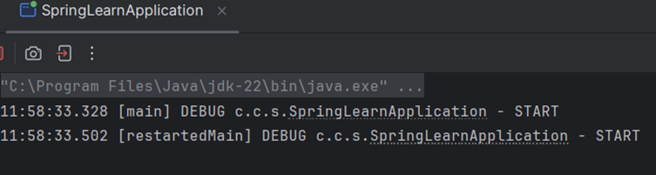

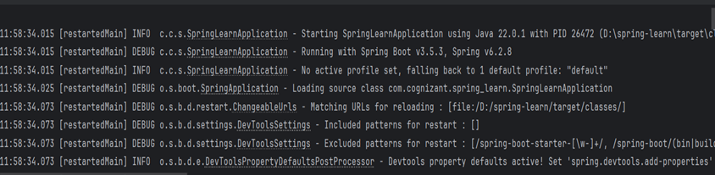

OUTPUT:

